**Experiment No. 5**

**Aim:** Modify the webpage by adding ordered list, unordered list, checkbox button and radio button.

**Code:**

Homepage.html

<!DOCTYPE html>

<html>

<head>

<meta charset="utf-8">

<meta name="viewport" content="width=device-width, initial-scale=1">

<title>Designers Pick- Online Shopping for Women and Mens</title>

<link rel="stylesheet" href="style.css">

</head>

<body >

<header>

<h1>DesignersPick</h1>

<nav>

<ul>

<li ><a href="#">Home</a></li>

<li ><a href="#">Customer Login</a></li>

<li ><a href ="#">Contact Us</a></li>

<li ><a href="#">Sign Up</a></li>

<li ><a href="#">Exchange or Return</a></li>

</ul>

</nav>

</header>

<center >

<ul >

<li ><img src=men.jpg width="200" height="400" border="5"><a href="men.html">MEN</a></li>

<li ><img src=women1.jpg width="200" height="400" border="5"><a href="women.html">WOMEN</a></li>

</ul>

</center>

<section>

<p>Varities Available </p>

</section>

<table >

<tr>

<th >Men</th>

<th >Women</th>

</tr>

<tr>

<td> Denim Jeans</td>

<td>Denim Jeans</td>

</tr>

<tr>

<td>Shirt</td>

<td>Tops</td>

</tr>

<tr>

<td>Accessories</td>

<td>Accessories</td>

</tr>

<tr>

<td>Bags</td>

<td>Handbags/Sling bags/Backpack</td>

</tr>

</table>

<p style="font:bold 40px Tahoma;padding-top:20px;padding-left:50px;" >List of Productss</p>

<ol>

<li>Shirt</li>

<li>T-Shirt</li>

<li>Jeans</li>

<li>Accessories</li>

<li>Tops</li>

<li>Belts</li>

<li>Bags</li>

</ol>

<form >

<p >Subscribe </p>

<h3> First name:</h3>

<input type="text" name="firstname">

<br><br>

<h3>Last name:</h3>

<input type="text" name="lastname">

<br><br>

<h3>Mail-Id:</h3>

<input type="text" name="mail-id" >

<br><br>

<h3>Gender:</h3>

<input type="radio" name="gender" value="male" checked > Male

<input type="radio" name="gender" value="female" > Female

<input type="radio" name="gender" value="other"> Other

<br><br>

<h3>Rating:</h3>

<input type="checkbox" name="rating" value="one"> One Star<br>

<input type="checkbox" name="rating" value="two" > Two Star<br>

<input type="checkbox" name="rating" value="three"> Three Star<br>

<input type="checkbox" name="rating" value="four" > Four Star<br>

<input type="checkbox" name="rating" value="five" > Five Star<br>

<br><br>

<input type="submit" value="Subscribe">

</form>

</body>

</html>

Men.html

<!DOCTYPE html>

<html>

<head>

<meta charset="utf-8">

<title>Men Shopping Online</title>

<link rel="stylesheet" href="style1.css">

</head>

<body>

<header>

<h1>DesignersPick</h1>

<nav>

<ul>

<li ><a href="#">Home</a></li>

<li ><a href="#">Customer Login</a></li>

<li ><a href ="#">Contact Us</a></li>

<li ><a href="#">Sign Up</a></li>

<li ><a href="#">Exchange or Return</a></li>

</ul>

</nav>

</header>

<center>

<img src=men2.jpg width="1000" height="450">

</center>

<h2 id="trend">#TRENDING</h2>

<p id="para">Fashion looks better when you feel good on the inside</p>

<img style="padding-top:50px;padding-left:90px;" src="men3.jpg" width="300" height="300"><img style="padding-top:50px;padding-left:150px;" src="men4.jpg" width="300" height="300"><img style="padding-top:50px;padding-left:155px;" src="footware1.jpg" width:"300" height="300" >

<center id="list">

<p style="font: bold 18px Tahoma;color:black;">CLOTHING</p>

<ul >

<li style="padding-top:10px;padding-bottom:10px;font:bold 15px Tahoma;"><a href="#">T-Shirts</a></li>

<li style="padding-top:10px;padding-bottom:10px;font:bold 15px Tahoma;"><a href="#"> Shirts</a></li>

<li style="padding-top:10px;padding-bottom:10px;font:bold 15px Tahoma;"><a href="#"> Suits</a></li>

<li style="padding-top:10px;padding-bottom:10px;font:bold 15px Tahoma;"><a href="#">Jeans</a></li>

<li style="padding-top:10px;padding-bottom:10px;font:bold 15px Tahoma;"><a href="#">Trousers</a></li>

<li style="padding-top:10px;padding-bottom:10px;font:bold 15px Tahoma;"><a href="#">Shorts</a></li>

<li style="padding-top:10px;padding-bottom:10px;font:bold 15px Tahoma;"><a href="#">TrackPants</a></li>

</ul>

<p style="font: bold 18px Tahoma;color:black;padding-top:20px;">FOOTWARE</p>

<ul >

<li style="padding-top:10px;padding-bottom:10px;font:bold 15px Tahoma;"><a href="#">Sports Shoes</a></li>

<li style="padding-top:10px;padding-bottom:10px;font:bold 15px Tahoma;"><a href="#">Formal Shoes </a></li>

<li style="padding-top:10px;padding-bottom:10px;font:bold 15px Tahoma;"><a href="#"> Sandals & Floaters </a></li>

<li style="padding-top:10px;padding-bottom:10px;font:bold 15px Tahoma;"><a href="#">Socks</a></li>

</ul>

<p style="font: bold 18px Tahoma;color:black;padding-top:20px;">ACCESSORIES</p>

<ul >

<li style="padding-top:10px;padding-bottom:10px;font:bold 15px Tahoma;"><a href="#">Watches & Wearables</a></li>

<li style="padding-top:10px;padding-bottom:10px;font:bold 15px Tahoma;"><a href="#">Sunglasses & Frames </a></li>

<li style="padding-top:10px;padding-bottom:10px;font:bold 15px Tahoma;"><a href="#"> Bags & Backpacks </a></li>

<li style="padding-top:10px;padding-bottom:30px;font:bold 15px Tahoma;"><a href="#">Wallets & Belts</a></li>

</ul>

</center>

</body>

</html>

Style.css

*{

margin: 0px;

padding: 0px;

}

body{

background-color:white;

padding:0px;

margin: :0px;

}

header{

width:100%;

position:fixed;

background: black;

color: white;

padding: 20px;

font: bold 20px Tahoma;

border-bottom: 5px solid darkseagreen;

}

nav ul li{

display: inline-block;

list-style: none;

padding:10px;

padding-bottom: 5px;

}

nav ul li a{

padding-top:10px;

padding-left:50px;

padding-right:50px;

color:white;

width:75%;

font: solid 15px Tahoma;

}

center{

width:100%;

height:100%;

display: inline-block;

margin:30px;

}

center ul li{

list-style: none;

padding:150px;

display: inline-block;

}

center ul li a {

display: inline-block;

color: black;

padding-right:20px;

padding-left:20px;

font: bold 20px Tahoma;

}

form p{

font: bold 40px Tahoma;

padding-top: 10px;

color:black;

margin: 15px;

}

section p {

font: bold 40px Tahoma;

padding:20px;

padding-left:50px;

color:black;

}

table{

width:40%;

margin:15px;

}

table, th, td {

border: 1px solid black;

border-collapse: collapse;

}

th, td {

padding: 5px;

}

th {

text-align: left;

}

form{

font: solid 20px Tahoma;

padding: 25px;

}

nav ul li a:hover {

color: silver;

text-decoration:none;

font-weight: none;

}

ol li{

padding-left:60px;

padding-top:10px;

}

Style1.css

*{

margin: 0px;

padding: 0px;

}

body{

background-color:white;

padding:0px;

margin: :0px;

}

header{

width:100%;

position:fixed;

background: black;

color: white;

padding: 14px;

font: bold 18px Tahoma;

border-bottom: 5px solid darkseagreen;

}

header h1{

padding-top: 6px;

padding-left: 5px;

}

h3{

display: inline-block;

float:left;

}

nav ul li{

display: inline-block;

list-style: none;

padding:8px;

}

nav ul li a{

padding-top:12px;

padding-left:49px;

padding-right:49px;

color:white;

width:75%;

font: solid 15px Tahoma;

}

nav ul li a:hover {

color: silver;

text-decoration: none;

font-weight: none

}

center

{

padding-top:150px;

}

#trend{

font: bold 20px Tahoma;

color:#404040;

float:left;

padding-top:40px;

padding-left:100px;

}

#para{

font:bold 15px Tahoma;

color:#909090;

padding-top:80px;

padding-left:100px;

}

**Output:**

**Homepage-**

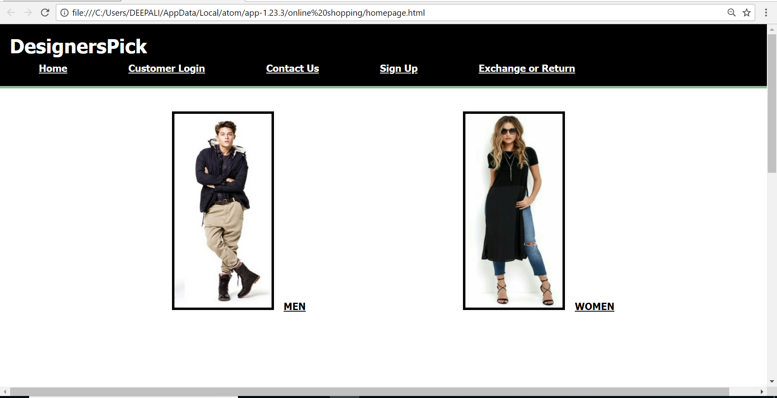

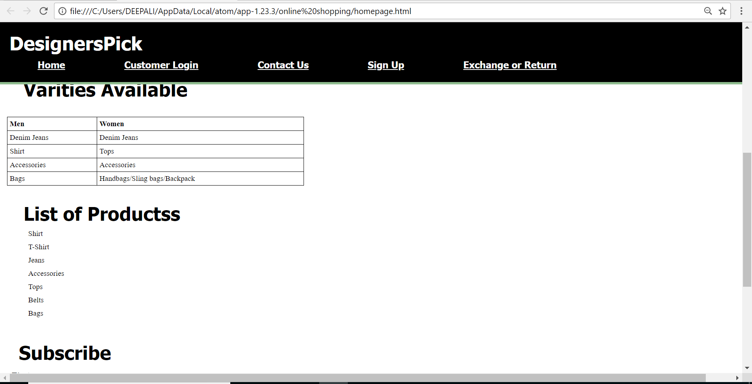

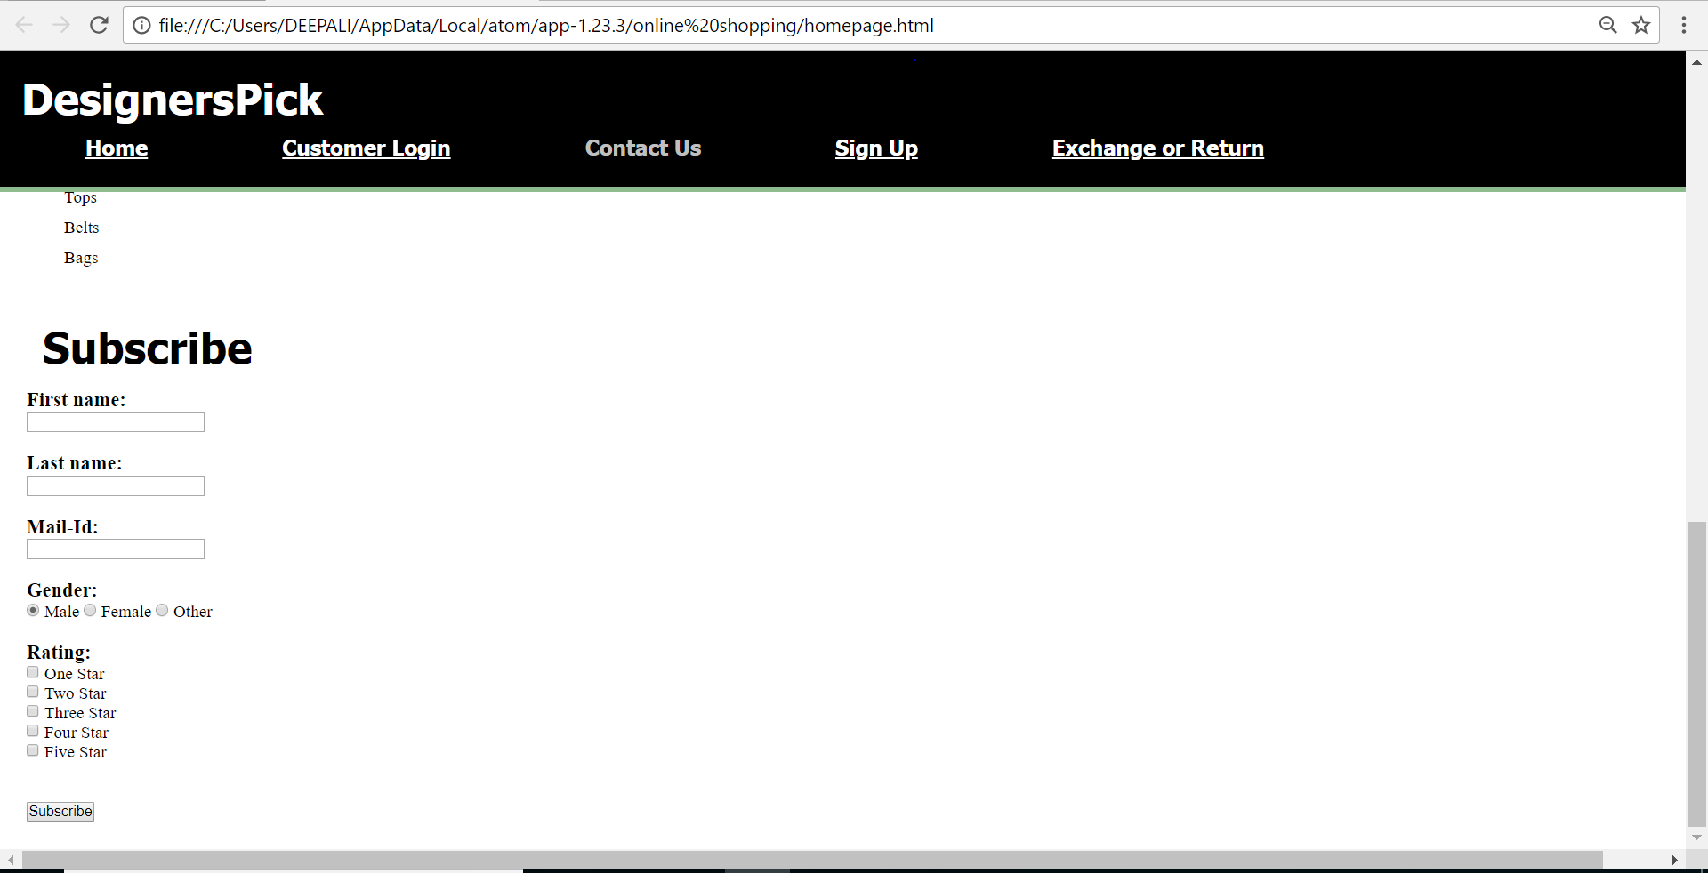

**Men page-**

